21 Things Portfolio Work Sheet
Revised 12-21-09

Participant Name: Melissa Schamper District: Eagle Crest_____________
Thing Name: Collaboration Tools Thing Number: ___4___ Time Logged: 3

Complete the following activities for the collaboration tools portion of the hands-on activity for Thing 4:
1. Open a Google Account.
2. Create a Google document and describe ways you see Google Documents can make you more productive. Make use of 3-4 formatting items on the toolbar, and invite a colleague, or classmate to collaborate by making some edits to the document.
3. Capture a screen shot (using Print-screen) and paste it into your portfolio. Include some reflections on how Google Documents can increase your productivity.
I was not really impressed with Google Docs at least with doing a power point. I found it very hard to manipulate and resize pictures that I had imported in. I was also having a hard time creating lines with arrows to point to certain parts of my images. I ended up redoing the power point in Microsoft Power Point as a method of review for our Ancient Rome test. When I uploaded the document into Google Docs, none of my images uploaded to each slide came through. It would be nice to share this power point with other teachers but with the images not uploading many of the slides don’t make much sense. I can see if maybe my power points were simpler that it would be useful.
Insert a Screen Shot below: 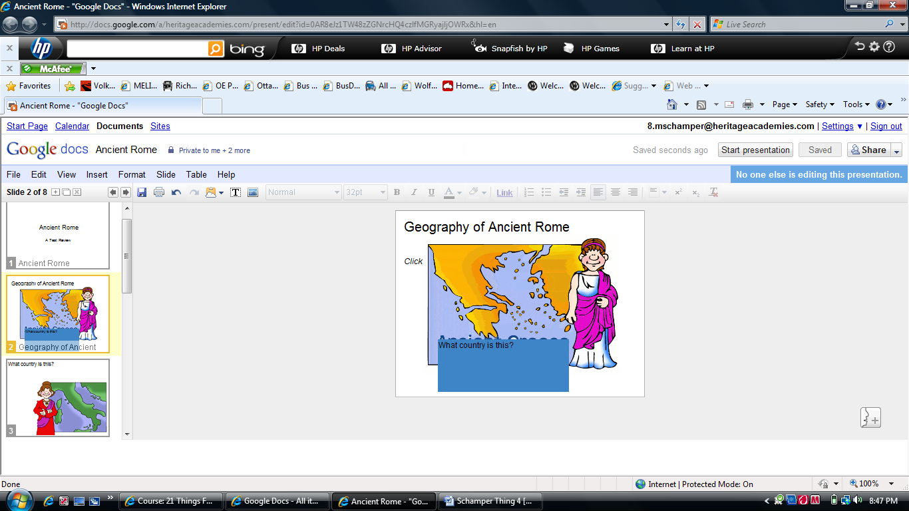

Reflection Part 1:
- Hands On Activity/Activities – Describe lesson/s you will use with your students.
The power point I created last night I was able to use as a test review for my class today. We viewed the power point and each slide had a question about Ancient Rome that might show up on the test. The class loved the clip art and I enjoyed interacting and reviewing with them in this new way.
Reflection Part 2:
- How will you use this technology application to improve learning experiences for your students and/or improve your own practice?
I think in the long run once more National Heritage Academies teachers get a Google Docs account we would be able to more easily create and share our formative assessments in each grade level. A corporate wide initiative to create assessments for every objective would be so much easier accomplished if all NHA were on Google Docs and could share our created assessments for ideas and to use as my own. A huge time saver.
- What effective teaching and learning strategy(ies), based on the work by Marzano (http://gets.gc.k12.va.us/VSTE/2008/ ) will this technology application address, to make a difference in the learning experience for your students?
• 2 ‐ Summarizing and note‐taking
• 6 ‐ Incorporate cooperative learning
- Describe an activity or lesson in your classroom, and the Michigan curriculum standard or Educational Technology standard you will be meeting, which uses this "thing".
I used the power point created as a way to review for our Ancient Rome test. Each slide had a different test review question on it and I had enough slides for each student in the class to have a chance to answer one question. I like how the clip art added value and hints to what the answer was I was looking for. That allowed me to differentiate where needed and helped students use picture clues to construct their answers.
1.b, 1.c, 1.d, 2.a, 2.b, 2.c, 2d, 3.a, 3.b, 3.c, 3d

Optional: Complete Activities 1-3 using Buzzword.

Self – Evaluation of your NETS-T Proficiency on this Thing (Please tell us where you think you are at upon completion).
Proficiency Score: | Score | Score | Score | Score | Score
Lickert Scale | 1 | 2 | 3 | 4 | 5
NETS-T Performance Proficiency | ------ | Beginning | Developing | Proficient | Transformative

