21 Things Portfolio Work Sheet
Revised 12-21-09

Thing Name: Podcasting Thing Number: ___14___ Time Logged: 3
Participant Name: Melissa Schamper District: Eagle Crest

Complete the following activities for podcasting portion of the hands-on activity for Thing 14:
1. Locate and listen to a podcast. Write a brief summary of the content and place this in your portfolio.
Reflections: I listened to a podcast from grammar girl on improving a resume by using parallel construction. I never realized how important it is to get all of your verbs in the right tense when listing duties or responsibilities. It does sound much better when you create all the verbs to sound the same way like all ending in an –ing or beginning all your phrases with the or not including the in each example. Being consistent was the message from grammar girl on improving resumes.
2. Create a podcast in Audacity, Gcast or GarageBand (Mac users). (Note: We recommend you purchase a headset with microphone for this activity. The built-in microphone in laptops leaves much to be desired in quality of the recording.)
Insert a Screen Shot below: 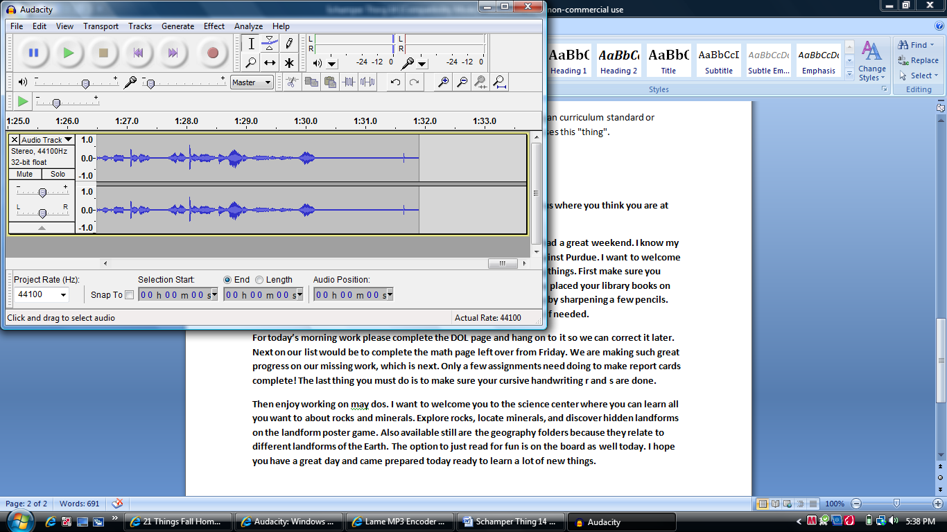
3. Post your podcast on your web site or Blog. There are several places you can upload your Podcasts. You can upload the podcast to your Blog that you created or your Weebly page, or in a course management program (Blackboard or Moodle). Once you upload it take a screen shot and make sure it includes the url to your podcast file so we can enjoy listening to it. Place the screen shot in your portfolio.
Insert a Screen Shot below:
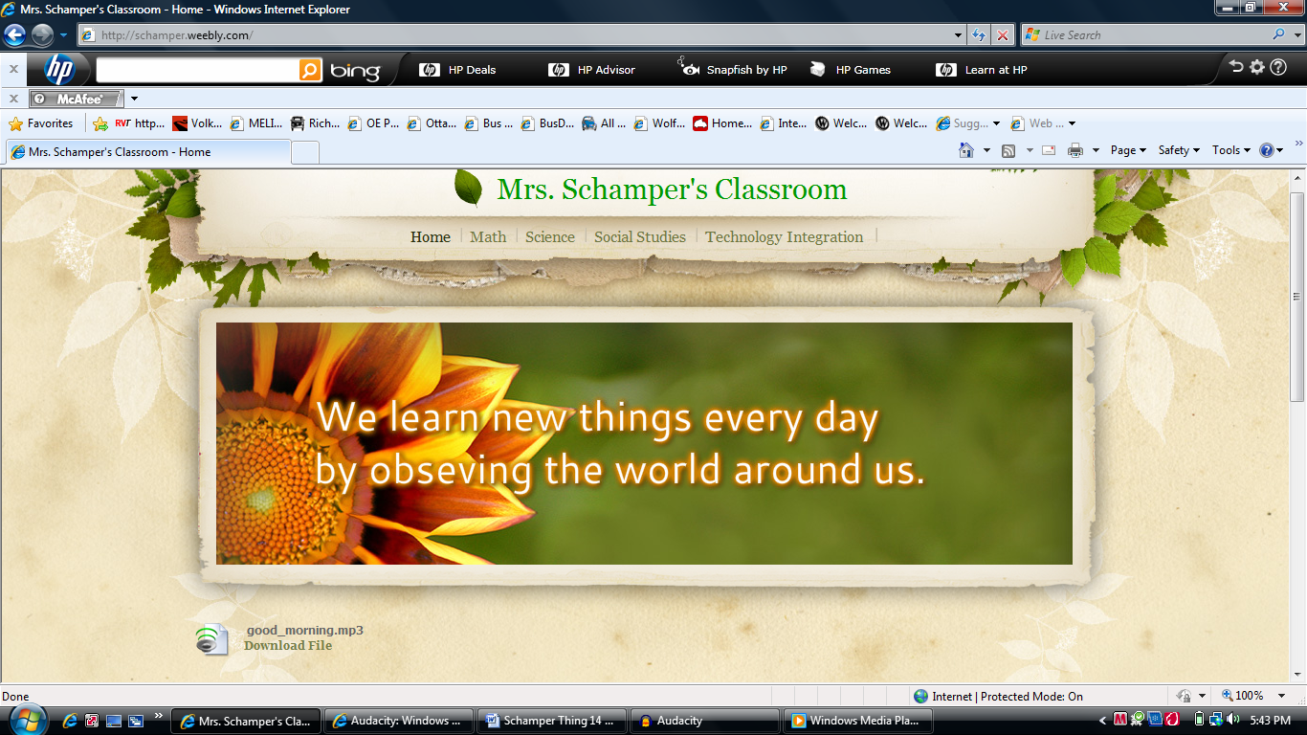
http://schamper.weebly.com/ is the site where I uploaded my podcast.
Reflection Part 1:
- Hands On Activity/Activities – Describe lesson/s you will use with your students.
I thought about placing my morning work routine on as a podcast. That way I remember to tell the class what I want to say beforehand. Also those students who are auditory learners can hear a rundown of the important announcements for the day. They can also listen to it as many times as they need to.
Reflection Part 2:
- How will you use this technology application to improve learning experiences for your students and/or improve your own practice?
I see this tool as a way to communicate with parents through a podcast. Newsletters are never big enough to type up all the important information so I could do an audio version of my newsletter available on my website to explain more important events that I could not normally explain in as much detail. Then for those interested parents they could log in to hear what extra information I have available to them.
- What effective teaching and learning strategy(ies), based on the work by Marzano (http://gets.gc.k12.va.us/VSTE/2008/ ) will this technology application address, to make a difference in the learning experience for your students?
14. Podcasting
• 5 ‐ Non‐linguistic representations
- Describe an activity or lesson in your classroom, and the Michigan curriculum standard or Educational Technology standard you will be meeting, which uses this "thing".
Another neat idea would be to post test review documents on my website. I always send home a paper copy but for those that loose the copy or again want a little more explanation, I could offer an audio version. That way students can log in and listen to the review pause it and try to come up with the information I have before playing it again to see if they remembered all of the information.
1.a, 1.b,1.c, 1.d, 2.a, 2.b, 2.c, 2.d 3.a, 3.c, 4.b
Self – Evaluation of your NETS-T Proficiency on this Thing (Please tell us where you think you are at upon completion).
Proficiency Score: | Score | Score | Score | Score | Score
Lickert Scale | 1 | 2 | 3 | 4 | 5
NETS-T Performance Proficiency | ------ | Beginning | Developing | Proficient | Transformative
(My transcript of what I wanted to say)
Good morning class it is Monday, November 15, 2010. I hope you all had a great weekend. I know my weekend was fantastic because Michigan won their football game against Purdue. I want to welcome you here this morning and hope you remembered to do the following things. First make sure you made your lunch choice. Secondly we have library today so I hope you placed your library books on the cart out in the hallway. Next be sure you are prepared for the day by sharpening a few pencils. Lastly, before starting on your morning work fill up your water bottle if needed.
For today’s morning work please complete the DOL page and hang on to it so we can correct it later. Next on our list would be to complete the math page left over from Friday. We are making such great progress on our missing work, which is next. Only a few assignments need doing to make report cards complete! The last thing you must do is to make sure your cursive handwriting r and s are done.
Then enjoy working on may dos. I want to welcome you to the science center where you can learn all you want to about rocks and minerals. Explore rocks, locate minerals, and discover hidden landforms on the landform poster game. Also available still are the geography folders because they relate to different landforms of the Earth. The option to just read for fun is on the board as well today. I hope you have a great day and came prepared today ready to learn a lot of new things.

