21 Things Portfolio Work Sheet
Revised 12-21-09

Participant Name: Melissa Schamper District: Eagle Crest _____________
Thing Name: Content Area Tools Thing Number: ___5___ Time Logged: 3

Complete the following activities for the content area tools portion of the hands-on activity for Thing 5:
1. Visit Thinkfinity
2. Choose at least one activity from ReadWriteThink and one from another Thinkfinity partner that will enhance a lesson you teach.
Insert a Screen Shot from READWRITETHINK below: 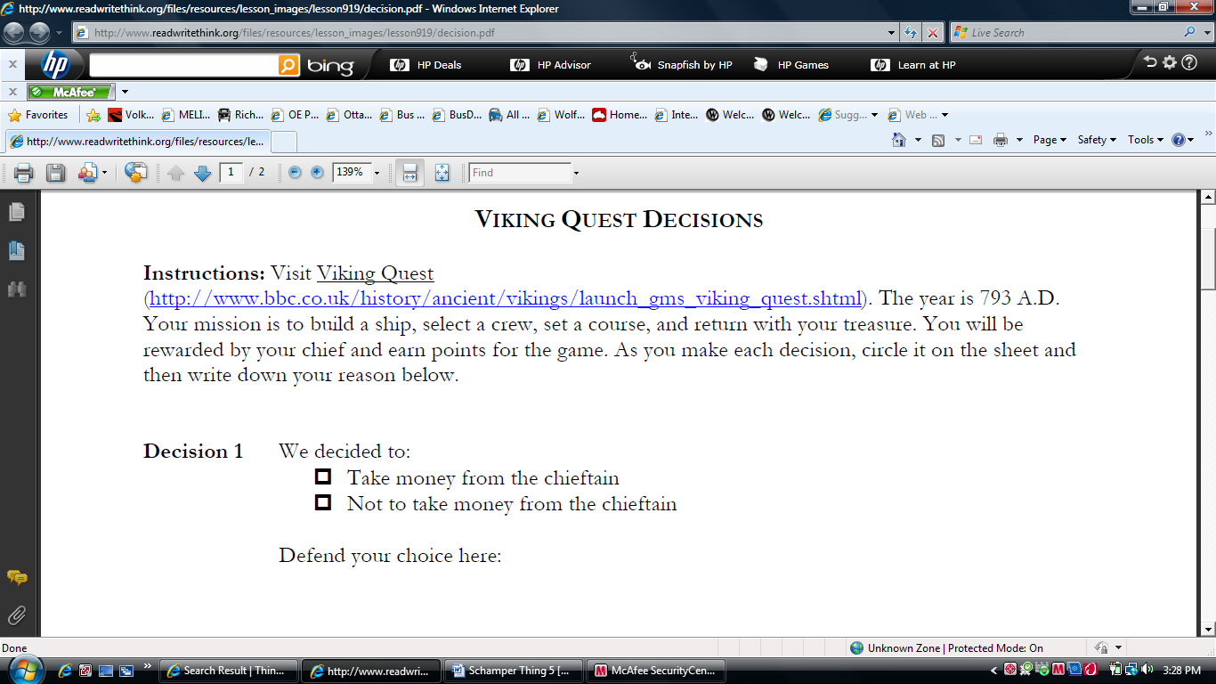

Insert a Screen Shot from Thinkfinity below: 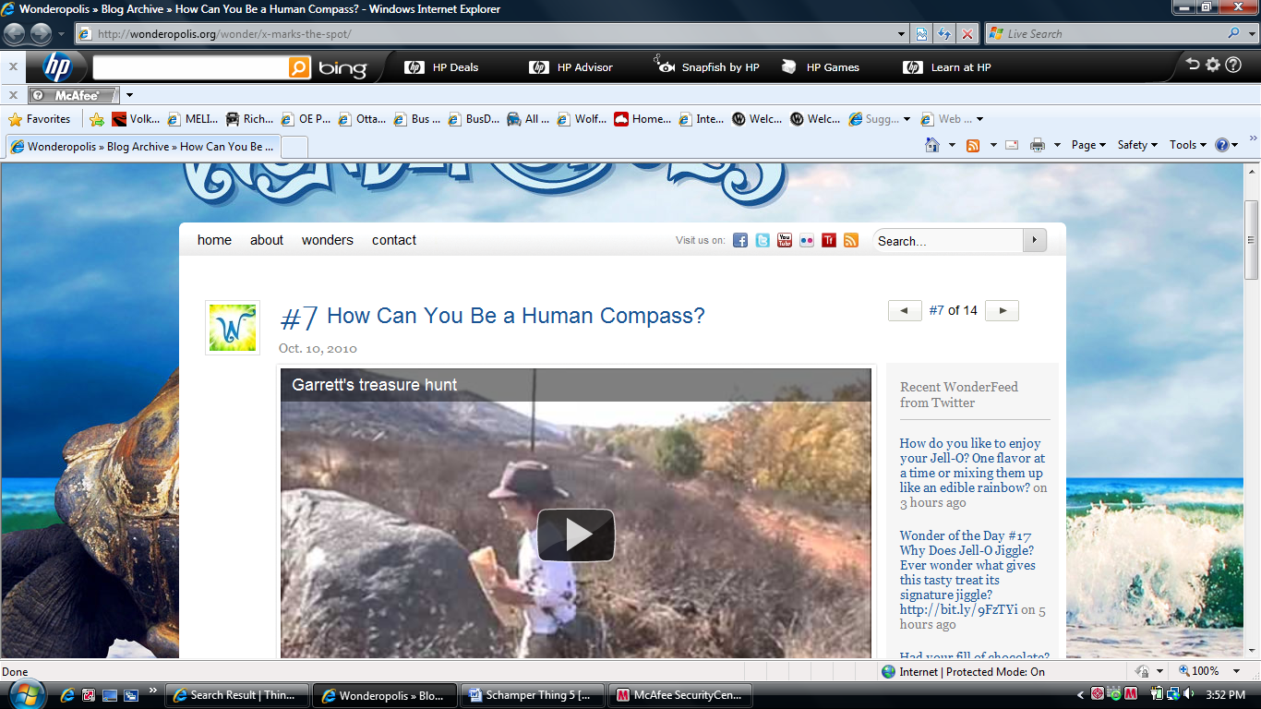

3. For the portfolio assignment, write a short synopsis of the activity and how you are going to use it within your lesson and be sure to include the hyperlink to the two activities from that web that you are using.
Viking Interactive
Wonderopolis
Reflection Part 1:
- Hands On Activity/Activities – Describe lesson/s you will use with your students.
I plan to use the first website Viking Interactive to have the class do as a culminating activity to our study of Vikings. The interactive encourages partner collaboration and decision making as they make their way through the thought process of a Viking raid. It is a neat hands on applicable way for my students to get a feel for what it would be like to be alive during the age of the Vikings. We can go down to the computer lab or check out the notebook cart to do the activity in the classroom. I like the print out page as well on a pdf where students have to defend the choices they make at each question. Good higher level thinking going on.
The other piece I discovered is a real life application of using directions. In our next unit after Vikings we will learn about cardinal directions during a day studying Geography. I plan to show this you tube clip to introduce the lesson and have the students make the connection of why we teach about the cardinal directions.
Reflection Part 2:
- How will you use this technology application to improve learning experiences for your students and/or improve your own practice?
The technology piece will improve the students higher order thinking skills in the first interactive. Based on the decisions they make their band of Vikings will either succeed or fail based on their decisions. The learning experience being hands on and visual will give them a better connection to learning about Vikings through various modes rather than just paper pencil in a paper packet.
Also through the you tube video students will see a real life application of using the cardinal directions.
- What effective teaching and learning strategy(ies), based on the work by Marzano (http://gets.gc.k12.va.us/VSTE/2008/ ) will this technology application address, to make a difference in the learning experience for your students?
• 8 – generating and testing hypothesis
• 9 – questions, cues, advanced organizers

Describe an activity or lesson in your classroom, and the Michigan curriculum standard or Educational Technology standard you will be meeting, which uses this "thing".
On my LCD projector I can show the you tube video to my class as an introduction to our study of directions in geography. It is neat to be able to relate our learning to real life and have the students connect to wanting to and needing a reason to know how to follow the cardinal directions.

1.a, 1.b, 2.a, 2.b, 2.c, 3.a, 3.c, 3.d, 4.b, 5.c

Self – Evaluation of your NETS-T Proficiency on this Thing (Please tell us where you think you are at upon completion).
Proficiency Score: | Score | Score | Score | Score | Score
Lickert Scale | 1 | 2 | 3 | 4 | 5
NETS-T Performance Proficiency | ------ | Beginning | Developing | Proficient | Transformative

