Thing Name: Face of the Classroom Thing Number: ___10___ Time Logged: 3
Participant Name: Melissa Schamper District: Eagle Crest______

Complete the following activities for face of the classroom portion of the hands-on activity for Thing 10:
1. Create your own web site using one of the Things or one of your own choosing.
2. Include at least three pages, text, images, documents and web-links. You may want to use your site as a means to demonstrate some of the things you have learned from this 21 Things course.
3. Include the URL to your site and a reflection about the ways you could use a web page creator to create a web presence.
URL: http://schamper.weebly.com
Reflection Part 1:
- Hands On Activity/Activities – Describe lesson/s you will use with your students.
I love this thing. I have always wanted an online webpage to communicate with my students. Now I can upload links to websites we use and work with in class. Students are continually asking for the site names and I have to write them down for them. Now I can simply give them one easy website and have them find the links to the websites that interest them. Now from home they can be on quality educational websites and extend their learning without even knowing they are “doing extra homework”.
Reflection Part 2:
- How will you use this technology application to improve learning experiences for your students and/or improve your own practice?
I plan to use this web page and add to it as the year progresses. As I show various websites, I will put links to them so my students can extend their learning at home. For me it is a nice way to stay organized and keep my favorite website links all in one place by subject area.
- What effective teaching and learning strategy(ies), based on the work by Marzano (http://gets.gc.k12.va.us/VSTE/2008/ ) will this technology application address, to make a difference in the learning experience for your students?
Face of Your Classroom
• 2 ‐ Summarizing and note‐taking
• 4 – homework and practice
• 5 – non‐linguistic representations
• 7 – setting
- Describe an activity or lesson in your classroom, and the Michigan curriculum standard or Educational Technology standard you will be meeting, which uses this "thing".
I already showed my class this website and how to access it. I want them to have access to the fun interactive lessons we do in class at home as well. I placed the web address in my newsletter so parents can access the site for their children.
2.a, 2.b, 2.c, 2.d, 3.a, 3.b, 3.c, 4.b, 4.c, 5.a, 5.d.
4. Capture a screen shot of your page(s) to include in the portfolio.
Insert a Screen Shot below:
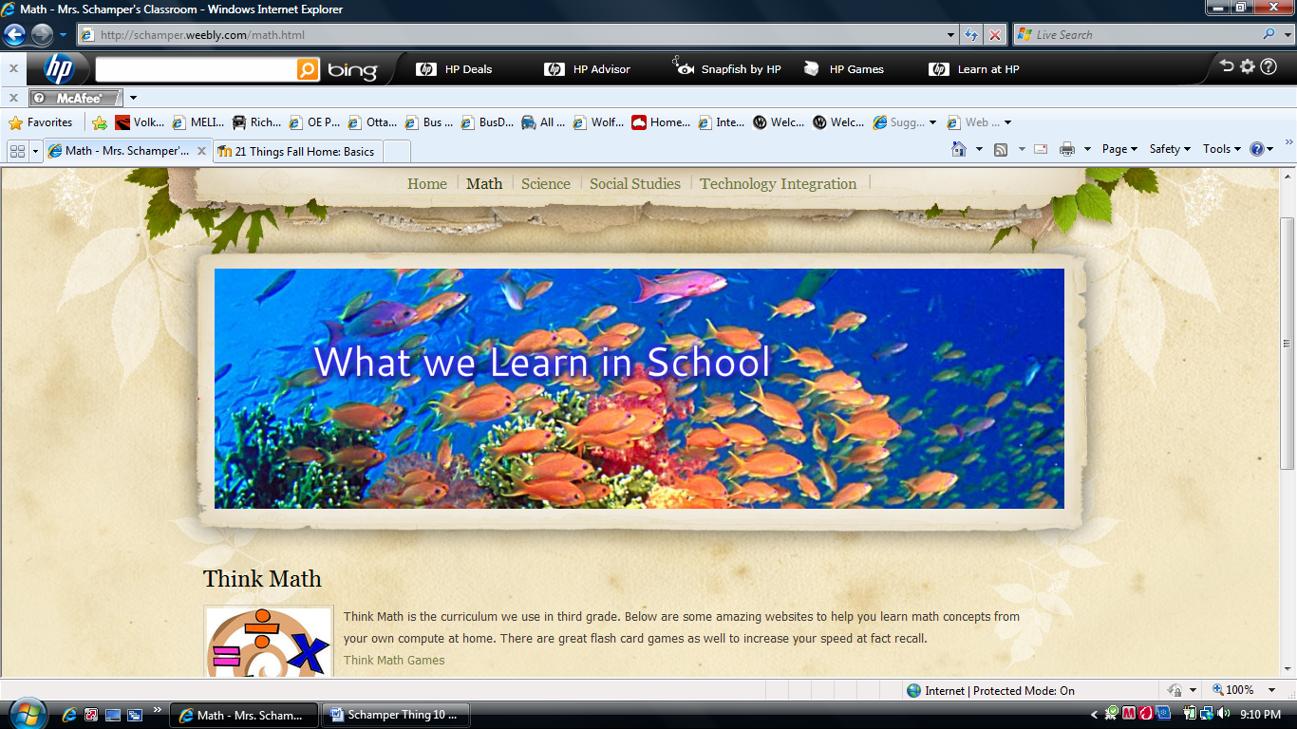
Proficiency Score: | Score | Score | Score | Score | Score
Lickert Scale | 1 | 2 | 3 | 4 | 5
NETS-T Performance Proficiency | ------ | Beginning | Developing | Proficient | Transformative
Self – Evaluation of your NETS-T Proficiency on this Thing (Please tell us where you think you are at upon completion).

